**REPORT OF ANALYSIS ON ADVANCEMENT IN SMART PHONE TECHNOLOGY**

*-Written by MUHAMMED SALIH K P*

*6 April,2019*

**INTRODUCTION**

Now we can’t imagine a world without smart phone. At the end of every month each company launches new models with more advanced technology. Smart phones are distinguished from feature phones by their stronger hardware capabilities and extensive [mobile operating systems](https://en.wikipedia.org/wiki/Mobile_operating_system), which facilitate wider [software](https://en.wikipedia.org/wiki/Application_software), [internet](https://en.wikipedia.org/wiki/Internet) and [multimedia](https://en.wikipedia.org/wiki/Multimedia) functionality, alongside core phone functions such as [voice calls](https://en.wikipedia.org/wiki/Telephone_call) and [text messaging](https://en.wikipedia.org/wiki/Text_messaging).

Based on operating system we can classify latest smartphones as Android phones, i Phones, Windows Phones. First android phone released on September, 2008. Now Android running on their latest version called Android Pie (version 9.0). After two years, Microsoft launched their first Windows phone in 2010. Apple released first i-phone in 2007. Android smartphones are most popular, they hold approx.. 80% of market share, In the case of i-phone its ~17%, In the case of windows its ~2%. The main reason for high popularity of Android is that its open source. Any company can use original or modified version of Android OS in their device.

In this analysis, we are going to review 10 latest Android mobile, 1 latest i-phone and 1 latest windows phone. We deeply covering processor, RAM and internal memory features, Latest technologies in smartphone Camera, Battery etc…Every procedure of this analysis is almost done within one day.

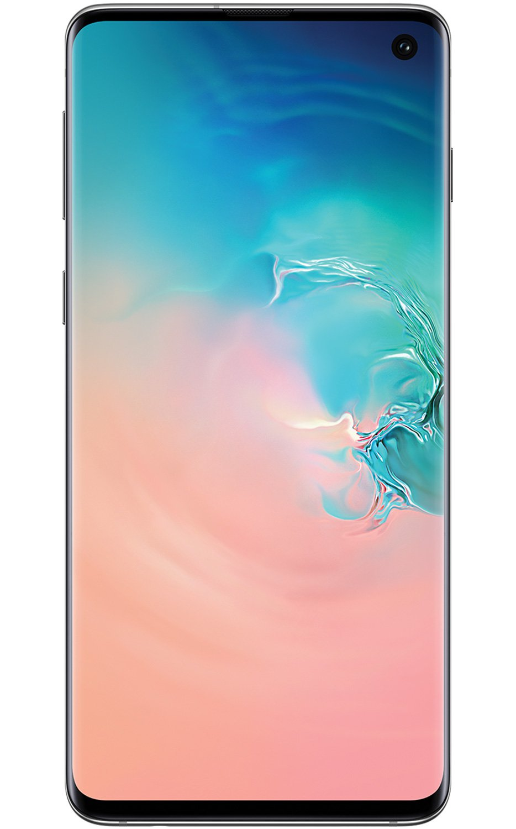

### [Apple iPhone XS Max](https://www.91mobiles.com/apple-iphone-xs-max-price-in-india)

iOS v12.0

Rs.107,010

**Expert comment:**   The most powerful iPhone from Apple also happens to ship with the largest display ever on an iPhone. With a 6.5-inch Super Retina display and A12 Bionic chipset, the iPhone XS Max delivers on all fronts. The phone is capable of recording stereo sound with videos. The ease of use that comes along with iOS is just an added bonus for a handset that packs commendable hardware. If money is not a factor, there is no doubt that iPhone XS Max is the best handset in the market. For smaller size, you can go for iPhone XS or iPhone XR, both good choices.

• Performance

Hexa Core (2.49 GHz, Dual Core + 1.52 GHz, Quad core)  
Apple A12 Bionic  
4 GB RAM

• Display

6.5 inches (16.51 cm)  
1242x2688 px, 456 PPI  
OLED

• Camera

12 MP + 12 MP Dual Primary Cameras  
Quad LED True Tone Flash  
7 MP Front Camera

• Battery

3174 mAh  
Fast Charging  
Non-Removable



### [Huawei Mate 20 Pro](https://www.91mobiles.com/huawei-mate-20-pro-price-in-india)

Android v9.0 (Pie)

Rs.64,990

**Expert comment:**   Huawei Mate 20 Pro is one of the best Android phones that you can buy right now. Premium head-turning design on the phone is beautifully complemented by a gorgeous OLED display. The 7nm Kirin 980 chipset, coupled with either 6GB or 8GB of RAM, make the Mate 20 Pro a beast in terms of performance. If we talk about optics, there is a triple camera setup at the back with a regular, telephoto, and a wide-angle lens. If this all was not enough, the phone can even be used to charge other devices with the wireless reverse charging support.

• Performance

Octa core (2.6 GHz, Dual Core + 1.92 GHz, Dual core + 1.8 GHz, Quad core)  
HiSilicon Kirin  
6 GB RAM

• Display

6.39 inches (16.23 cm)  
1440x3120 px, 538 PPI  
OLED

• Camera

40 MP + 20 MP + 8 MP Triple Primary Cameras  
LED Flash  
24 MP Front Camera

• Battery

4200 mAh  
Super Charging 2.0  
USB Type-C port



### [Samsung Galaxy S10e](https://www.91mobiles.com/samsung-galaxy-s10-e-price-in-india)

Android v9.0 (Pie)

Rs.55,900

**Expert comment:**   Samsung Galaxy S10e is one of the smallest flagships launched in a long from Samsung. Despite featuring a small form factor, the handset does not compromise on specifications and offers the same processing chipset as the Galaxy S10+ and the Galaxy S10. The S10e packs a 5.8-inch QHD+ Super AMOLED display and packs 6GB of RAM and 128GB of built-in storage, which is further expandable up to 512GB. The handset comes with a dual camera setup at the back and holds the fingerprint scanner on the right side. Don't be deceived by the size as this handset is a tank.

• Performance

Octa core (2.73 GHz, Dual Core + 2.31 GHz, Dual core + 1.95 GHz, Quad core)  
Samsung Exynos 9 Octa  
6 GB RAM

• Display

5.8 inches (14.73 cm)  
1440x2280 px, 465 PPI  
Dynamic AMOLED

• Camera

12 MP + 16 MP Dual Primary Cameras  
LED Flash  
10 MP Front Camera

• Battery

3100 mAh  
Fast Charging  
USB Type-C port



### [Samsung Galaxy Note 9](https://www.91mobiles.com/samsung-galaxy-note-9-price-in-india)

Android v8.1 (Oreo), upgradable to v9.0 (Pie)

Rs.61,899

**Expert comment:**   The latest entry to the list, Samsung Galaxy Note9 comes with all the great features from last year's Galaxy Note8 but with notable improvements. The Galaxy Note9 features a massive 4,000mAh battery and comes with a brand new S-Pen that serves as a remote that can help you click pictures when at a distance from the handset. The new flagship from the company is available with up to 512GB of built-in storage that can be further expanded via microSD card up to a whopping 1TB.

• Performance

Octa core (2.7 GHz, Quad Core + 1.7 GHz, Quad core)  
Samsung Exynos 9 Octa  
6 GB RAM

• Display

6.4 inches (16.26 cm)  
1440x2960 px, 514 PPI  
Super AMOLED

• Camera

12 MP + 12 MP Dual Primary Cameras  
LED Flash  
8 MP Front Camera

• Battery

4000 mAh  
Quick Charging 2.0  
USB Type-C port



### [Honor View 20](https://www.91mobiles.com/honor-view-20-price-in-india)

Android v9.0 (Pie)

Rs.37,999

**Expert comment:**   Honor View 20 comes with some top-of-the-line specs at an affordable price. The performance on the phone is driven by extremely capable Kirin 980 SoC, which is based on the 7nm fabrication process. Additionally, the handset packs a 48MP rear camera, alongside a 3D ToF sensor, to provide for a brilliant optics performance. The View 20 also happens to be the first phone in the market to feature a punch-hole display.

• Performance

Octa core (2.6 GHz, Dual Core + 1.92 GHz, Dual core + 1.8 GHz, Quad core)  
HiSilicon Kirin  
6 GB RAM

• Display

6.4 inches (16.26 cm)  
1080x2310 px, 398 PPI  
IPS LCD

• Camera

48 MP Primary Camera  
LED Flash  
25 MP Front Camera

• Battery

4000 mAh  
Super Charging  
USB Type-C port



### [OnePlus 6T](https://www.91mobiles.com/oneplus-6t-price-in-india)

Android v9.0 (Pie)

Rs.34,999

**Expert comment:**   Following the footsteps of the OnePlus 6, the OnePlus 6T comes with some interesting changes over its predecessor. The new handset from OnePlus features and in-display fingerprint sensor and a dewdrop notch design, increasing the screen-to-body ratio even further. The impressive cameras on the handset offer great detail as well as dynamic range, along with an added nightscape feature that allows users to click impressive shots even in poor lighting conditions. Overall, the blazing fast OnePlus 6T is one of the best phones in the market.

• Performance

Octa core (2.8 GHz, Quad Core + 1.8 GHz, Quad core)  
Snapdragon 845  
6 GB RAM

• Display

6.41 inches (16.28 cm)  
1080x2340 px, 402 PPI  
Optic AMOLED

• Camera

16 MP + 20 MP Dual Primary Cameras  
Dual LED Flash  
16 MP Front Camera

• Battery

3700 mAh  
Dash Charging  
USB Type-C port



### [Xiaomi Poco F1](https://www.91mobiles.com/xiaomi-poco-f1-price-in-india)

Android v8.1 (Oreo), upgradable to v9.0 (Pie)

Rs.17,999

**Expert comment:**   Xiaomi's Poco F1, also called Pocophone F1, is the best value-for-money smartphone available in the market. The handset comes with flagship-grade Snapdragon 845 processor at an extremely affordable price point. Xiaomi's new sub-brand's first smartphone does not only offer great performance but also packs some capable cameras and a massive 4,000mAh battery. If you like gaming on your handset and have certain budget constraints, this might be the best smartphone available for you.

• Performance

Octa core (2.8 GHz, Quad Core + 1.8 GHz, Quad core)  
Snapdragon 845  
6 GB RAM

• Display

6.18 inches (15.7 cm)  
1080x2246 px, 403 PPI  
IPS LCD

• Camera

12 MP + 5 MP Dual Primary Cameras  
LED Flash  
20 MP Front Camera

• Battery

4000 mAh  
Quick Charging 3.0



### [Xiaomi Redmi Note 7 Pro 128GB](https://www.91mobiles.com/xiaomi-redmi-note-7-pro-128gb-price-in-india)

Android v9.0 (Pie)

Rs.16,999

**Expert comment:**   Xiaomi faced some stiff competition in this price range last year but the brand's new Redmi Note 7 Pro is already looking like the best mid-range smartphone launched this year. The handset comes with an extremely capable Snapdragon 675 SoC a whopping 48MP rear camera for capturing details. The phone comes with a glass sandwich design and has Gorilla Glass 5 protection on both sides. If you are looking for an all-rounder phone at budget, Redmi Note 7 Pro is probably your best bet.

• Performance

Octa core (2 GHz, Dual Core + 1.7 GHz, Hexa Core)  
Snapdragon 675  
6 GB RAM

• Display

6.3 inches (16 cm)  
1080x2340 px, 409 PPI  
IPS LCD

• Camera

48 MP + 5 MP Dual Primary Cameras  
LED Flash  
13 MP Front Camera

• Battery

4000 mAh  
Quick Charging 4.0



### [Xiaomi Redmi Note 7 64GB](https://www.91mobiles.com/xiaomi-redmi-note-7-64gb-price-in-india)

Android v9.0 (Pie)

Rs.12,799

**Expert comment:**   Every year Xiaomi's Redmi Note series smartphones enter this list post launch as these handsets are known to offer great value for money. This year, Redmi Note 7 has managed to raise the benchmark even higher as the brand managed to include a capable Snapdragon 660 SoC in its offering under the Rs 10,000 price point. Apart from the processor, the phone comes with an FHD+ display, a massive 5,000mAh battery, and a USB Type-C port to offer the best all-rounder phone in this price segment.

• Performance

Octa core (2.2 GHz, Quad Core + 1.8 GHz, Quad core)  
Snapdragon 660  
4 GB RAM

• Display

6.3 inches (16 cm)  
1080x2340 px, 409 PPI  
IPS LCD

• Camera

12 MP + 2 MP Dual Primary Cameras  
LED Flash  
13 MP Front Camera

• Battery

4000 mAh